1. Meng only found bulk density, no Soil C data was found from the PDF.

***[Response from Blanca]*** *This paper is about N, it doesn’t have C data. This is not the paper used for the dataset. Another option is that there is a mistake, but you should confirm that there is no other Delaune paper from 1986 first.*

*--looks like this data was also from Neubauer´s excel. Check it out. He had original data from authors.*

The aboveground plant data was from Table 1 in control plot.

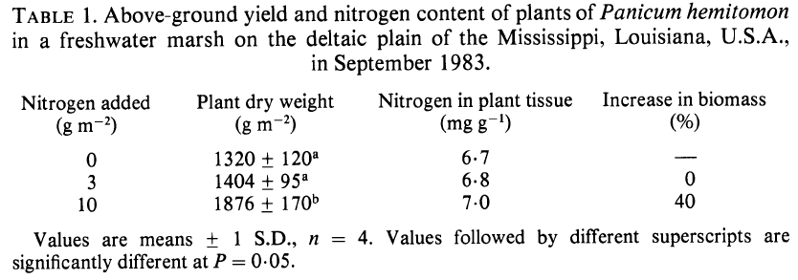

The paper does not report carbon density directly. We calculated carbon density from OM content and bulk density, but not carbon concentration. To calculate carbon density, their data were entered into a spreadsheet, then processed with SAS code to calculate carbon density. The calculation steps were as follows:

a. Convert organic matter (OM) to organic carbon units.

We used the following equation developed by James Holmquist (in review):

SoilCC=0.074*(OM/100)*(OM/100) + 0.421*(OM/100) - 0.0080, where

SoilCC = C concentration in units of grams C per grams soil

OM = organic matter concentration in units of grams OM per grams soil

b. Convert soil carbon concentration (SoilCC) to carbon density.

SC=SoilCC*BD, where

SC=Soil carbon density in units of grams carbon per cubic centimeter (g/cm3)

Soil C rate data was calculated as:

SC rate = SC * accumulation rate*10000;

As accumulation rate was provided as 0.75 cm yr-1 as 137Cs data.